Dance Company Tryouts 2017-2018

Dance Company Requirements

Tryout Packet
-Dancers will turn this in as they walk into tryouts Monday May 22nd. If dancers do not have their dance packets they will not be a allowed to tryout
- Current photo. The photo can be scanned in, printed or be a loose photo stabled or paper clipped to packet.
- Blank word document in the center please state name and grade for next year along with contact info- Page 1
- Clearance packet- turn into office before. Dancers need to turn in signature completion form stating your packet is complete- Page 2
http://www.ylhs.org/apps/pages/index.jsp?uREC_ID=67297&type=d&pREC_ID=106522
- Make sure to have your parents fill out the DMV risk management form because we do not take the bus.
- Or go to ylhs.org click on “athletics” and then clearance “forms”
- Grade report of all grades in current school ( 8th graders put your junior high grades) - Page 3
- 2 letters of rec all from school teachers (past or present)- Page 4 and 5
- Letter of recs need to be about your teachers experience with you as a student, your interaction peers and teachers, your personality and work ethics in their class.
- Schedule conflict paper. Paper on our website- Page 6
- Example Packet on our website
Day One Monday May 22nd 4-7pm in the small gym
- - technique cuts
- - learn the routine (hip hop, jazz, contemporary) cuts
Day Two Tuesday May 23rd 4-7pm in the small gym
- -There will be call backs posted on our website and in class case in foyer of gym
- - Tuesday May 23rd start with solo cuts and mini interviews
- -Back to large dance- cuts
- -Last minute questions-Final cut
Attire- whatever you want that makes you feel comfort please bring tennis shoes for hip hop and jazz shoes for everything else

Solo must be one minute to a minute and a half, whatever genre is your strongest style. No Tap

Example

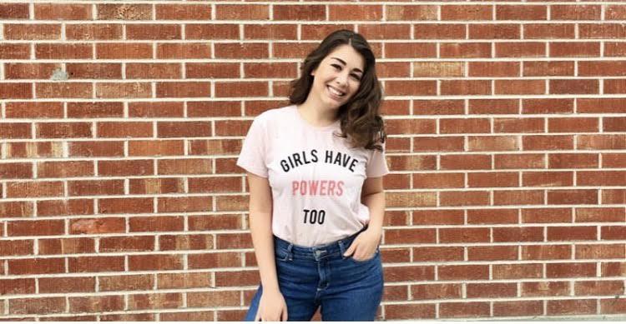

Example

Emmy Smith
12th Grade
714-123-6789
Email:emmysmith@yahoo.com

Example

__________________ (print name) has completed all parts of their clearance packet and is cleared to tryout

__________________Date

__________________Office Signature


Dance Company Clearance Packet Form

Example
December 2nd, 2016
To Whom This May Concern,
Emmy has been a dancer on Dance Company for the last 3 years here at Yorba Linda High School. She is positive an easy to work with. She is respectful and gracious with everyone. Emmy has been a student of mine for 3 years now and has shown great improvement not only in here dancing abilities but as a student as well. Emmy is one of the hardest working students I have a does this daily in our dance classes. In just a few years’ time she has moved from beginning to advanced dance. I can always count on Emmy to be a positive role model to her fellow classmates and help creative an up lifting vibe in the classroom.
Emmy is on time, dressed out every day and ready to learn. Emmy is active on campus, maintains good grades and has a great attitude while doing so. Emmy often volunteers to be an example in class which shows signs of integrity and eagerness to learn. Emmy has great attendance and follows all school rules.
I never have to remind her to turn assignments in or ask her to pay attention in class. Emmy has taken on a role of being one of the people in charge of hip hop club this year which shows great organization and leadership. I’m excited to see Emmy Smith accomplish another year of growth as a student here at YLHS.
Meshell Maes
Dance Program Director/ Teacher at Yorba Linda High School

Example
December 2nd, 2016
To Whom This May Concern,
Emmy has been a dancer on Dance Company for the last 3 years here at Yorba Linda High School. She is positive an easy to work with. She is respectful and gracious with everyone. Emmy has been a student of mine for 3 years now and has shown great improvement not only in here dancing abilities but as a student as well. Emmy is one of the hardest working students I have a does this daily in our dance classes. In just a few years’ time she has moved from beginning to advanced dance. I can always count on Emmy to be a positive role model to her fellow classmates and help creative an up lifting vibe in the classroom.
Emmy is on time, dressed out every day and ready to learn. Emmy is active on campus, maintains good grades and has a great attitude while doing so. Emmy often volunteers to be an example in class which shows signs of integrity and eagerness to learn. Emmy has great attendance and follows all school rules.
I never have to remind her to turn assignments in or ask her to pay attention in class. Emmy has taken on a role of being one of the people in charge of hip hop club this year which shows great organization and leadership. I’m excited to see Emmy Smith accomplish another year of growth as a student here at YLHS.
Meshell Maes
Dance Program Director/ Teacher at Yorba Linda High School

Example

Based off of your schedule next year please state any scheduling conflicts or activities you will be involved in next year

1
2
3
4
5
6
7
8
9
10

